# **GOVERNMENT POLYTECHNIC, NASHIK**

## (An Autonomous Institute of Govt. Of Maharashtra)



**PROJECT REPORT ON**

**“HOSPITAL MANAGEMENT SYSTEM”**

**FOR THE COURSE**

**THIRD YEAR DIPLOMA IN COMPUTER TECHNOLOGY**

**SUBMITTED BY**

**Miss. Pawar Riddhi Arun(176144)**

**Miss. Kothawade Neha Ravindra (176127)**

**Miss. Narkhede Ashlesha Atul(176135)**

**Miss. Mahajan Ritu Yuvraj(176130)**

**GUIDED BY**

**SHRI. Y.B. SANAP**

**SUBMITTED TO**

**GOVERNMENT POLYTECHNIC, NASHIK**

**ACADEMIC YEAR 2019-2020**

**GOVERNMENT POLYTECHNIC, NASHIK**

**(An Autonomous Institute of Govt. Of Maharashtra)**



**CERTIFICATE**

This is to certify that, the project Report on “**Hospital Management System”** has been successfully completed by project team in the fulfilment of requirement of Diploma in **“Computer Technology”** from **“Government Polytechnic, Nashik (An autonomous institute of Government of Maharashtra)”** during the Academic Year 2019-2020. It is record of their work carried in my guidance. They have satisfactorily completed this project.

## Guided By

Shri. Y. B. Sanap

**H.O.D**

Shri. Y. B. Sanap

**Principal**

Shri. D. P. Nathe

Government Polytechnic, Nashik

**ACKNOWLEDGEMENT**

We hereby, submit the project report on “Hospital Management System”. We are thankful to the Department of Computer Technology, Government Polytechnic, Nashik for providing us with the best of facilities for completing our project.

A successful project is a result of good term work, which contains not only the people who put in their logic and hard work but also the people who guide them.

We are extremely grateful for the necessary information, with support provided by Prof. Y.B. Sanap. It is just because of him that we could complete the project which we envisaged couple of weeks before. We would also like to thank for his constant encouragement and guidance.

Last but not the least we would like to thank all our fellows who have helped us directly and indirectly in our project.

## Submitted By

Miss. Pawar Riddhi Arun(176144)

Miss. Kothawade Neha Ravindra (176127)

Miss. Narkhede Ashlesha Atul(176135)

Miss. Mahajan Ritu Yuvaraj(176130)

(Third Year Computer Technology.)

Government Polytechnic Nashik.

**ABSTRACT**

In this Project we aim to solve the traditional issues of hospital management. The existing system provided paper based solution for keeping OPD records of patients and hospital staff, but it gives overload to Doctor, Receptionist and Administrator. The main issues were inappropriate data keeping, time wastage in storage, retrieval also patients were unable to understand the prescription etc.

These issues are solved by providing a separate user account for doctors and other staff. Keeping each patient’s data separate and track previous visits in a single click.

This project uses MYSQL as backend and is developed in Java so it provides features such as platform independence, high performance and security. It is a web application which mainly uses SpringMVC and Hibernate frameworks.

It provides some enhanced features such as: an easy interface to add, remove employees as well as it provides PDF of prescription. Thus, reducing need to manually write and sign by doctor.

YouTube link: <https://youtu.be/SwE4mxQxhEI>

GitHub Link: <https://github.com/rid17pawar/HospitalManagement.git>

Sponsership Letter:

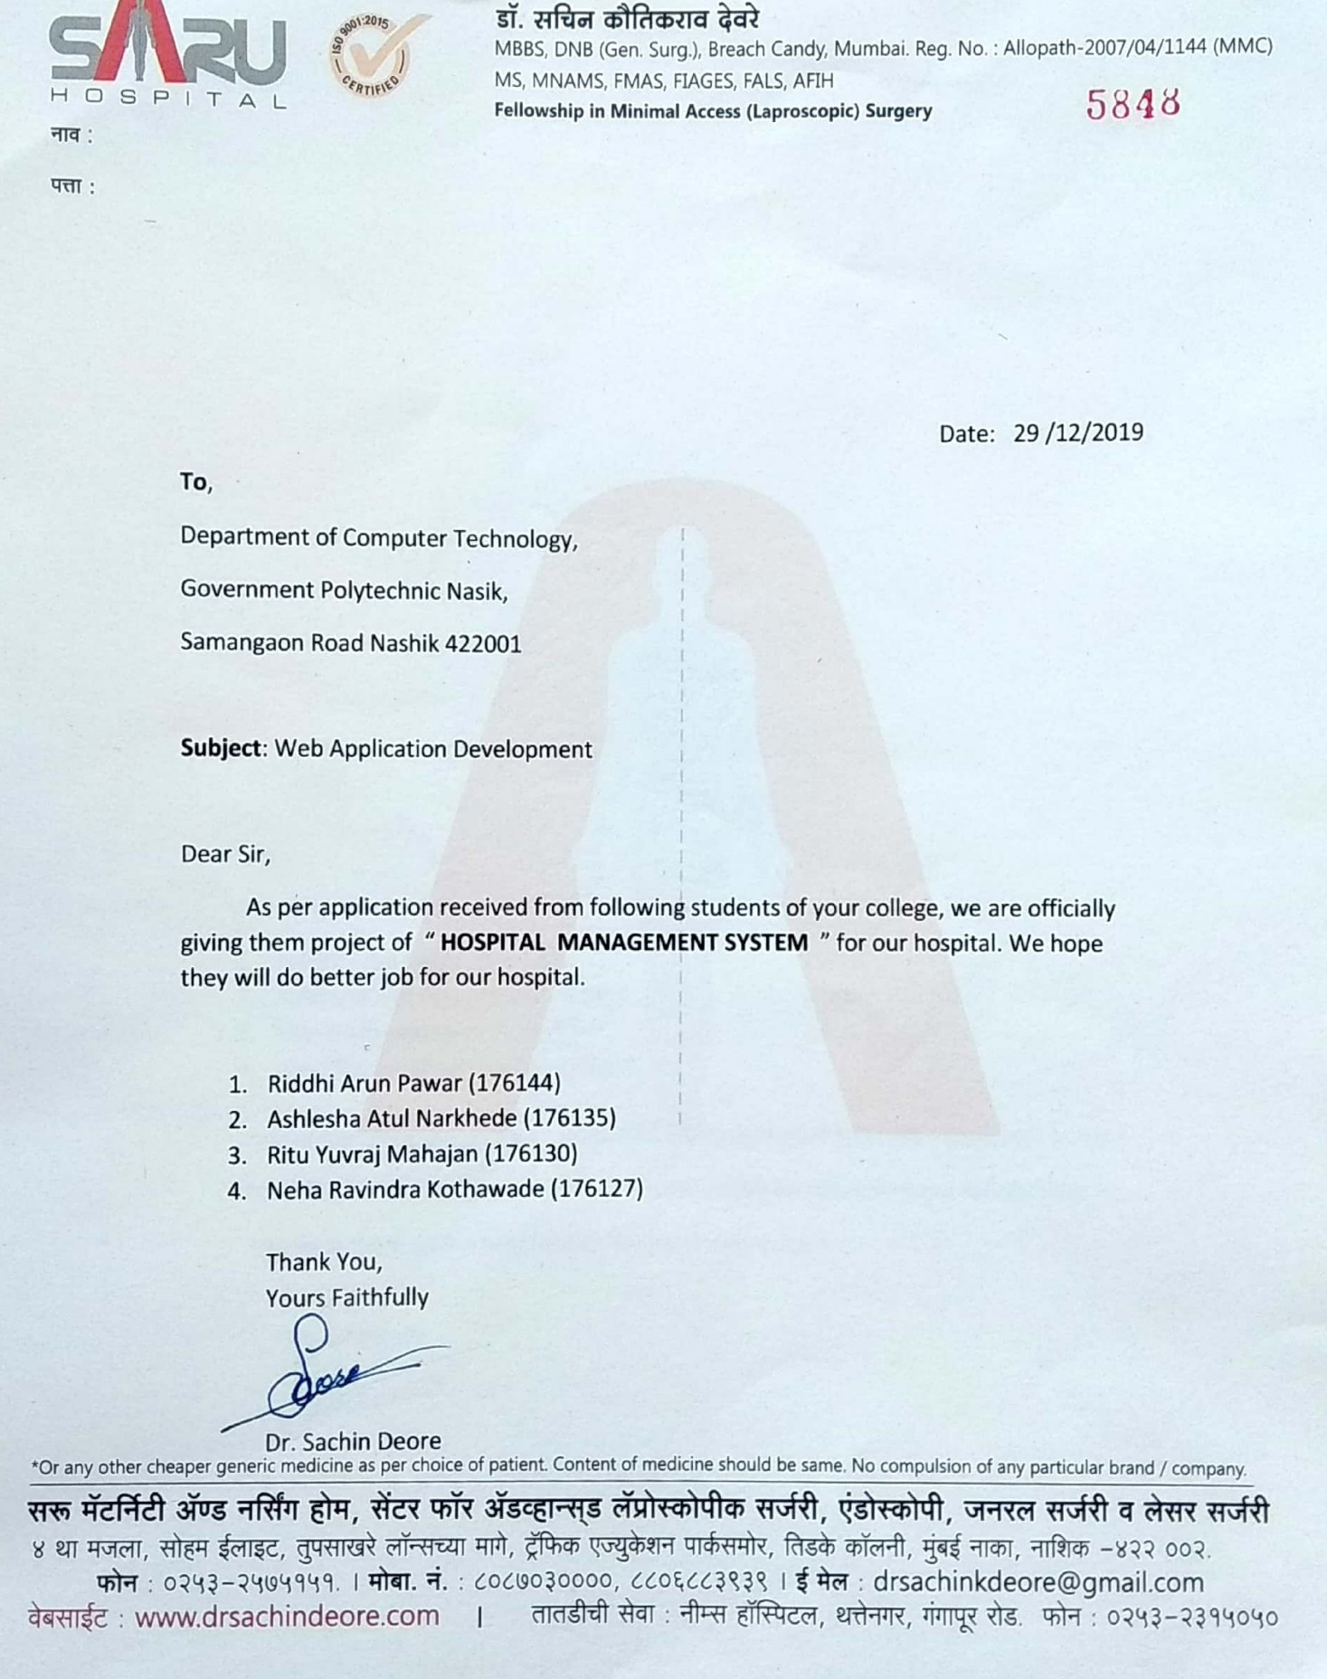

Completion Letter:

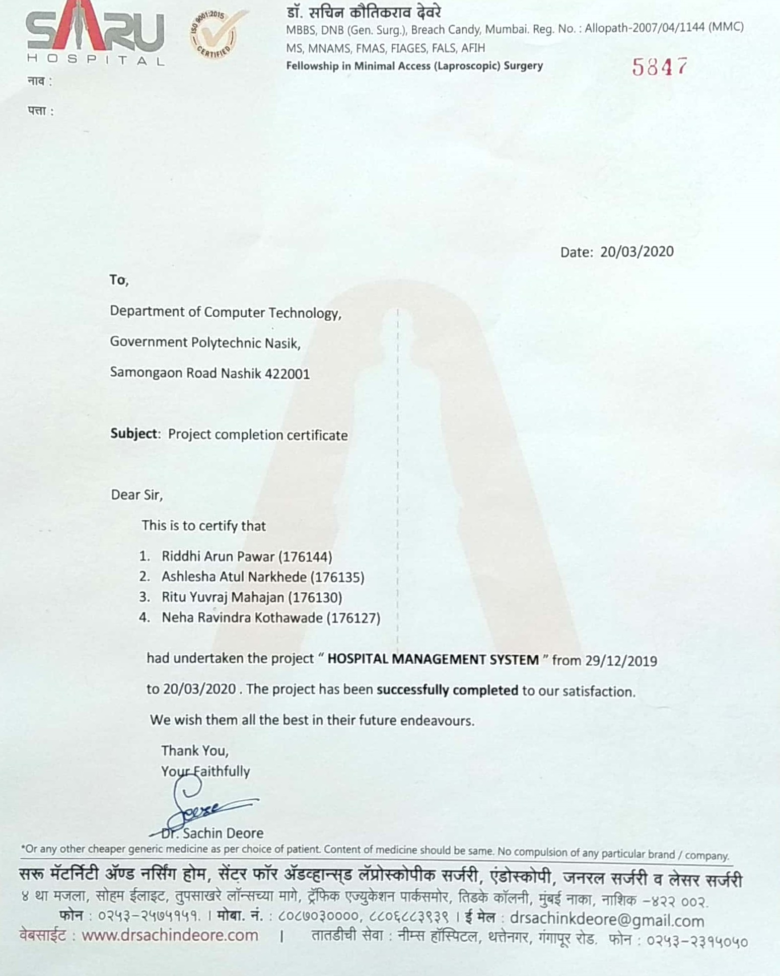

## INDEX

|  |  |  |
| --- | --- | --- |
| **Sr.**  **No.** | **Chapter Name** | **Page**  **No.** |
| **1** | **Introduction**   * 1. Existing System   2. Existing System Drawbacks   3. Proposed System | **9** |
| **2** | **System Design and Architecture**  2.1E-R Diagram  2.2 Activity Diagram(Receptionist)  2.3 Activity Diagram(Admin)  2.4 Activity Diagram(Doctor) | **11** |
| **3** | **Software Engineering Adapted Methodologies**  3.1 Methodology  3.2 Advantages of Incremental Model  3.3 Disadvantages of Incremental Model | **15** |
| **4** | **Requirement analysis & Feasibility Studies**  4.1 Software Requirement Specification  4.2 IDE Used  4.3 Server Used  4.4 Language Used  4.5 Frameworks Used  4.5.1 SpringMVC  4.5.2 Hibernate  4.6 Browser Used  4.7 Hardware Specification  4.8 Database and other software specification | **17** |
| **5** | **Project User Interface Designing**  5.1 Screenshots | **25** |
| **6** | **Feasibility study and System Testing**  6.1 Feasibility study  6.2 Testing | **30** |
| **7** | **System Implementation**  7.1 Implementation  7.2 Web Application  7.3 Database Design  7. 4 Database schema of Hospital Management System | **37** |
| **8** | **Other Aspects**  8.1 Advantages  8.2 Limitations  8.3 Applications  8.4 Future plan | **39** |
| **9** | **Conclusion And Reference**  9.1 Conclusions  9.2 References | **40** |

**CHAPTER 1**

**Introduction**

Human Body is a very complex and sophisticated structure and comprises of millions of functions. All these complicated functions have been understood by man, part-by-part through their research and experiments.

As science and technology progressed, medicine became an integral part of the research. Gradually, medical science became an entirely new branch of science. As of today, the Health Sector comprises of Medical institutions i.e. Hospitals, research and development institutions and medical colleges.

Thus the Hospital management system aims at providing the best medical facilities to the common man needs.

* 1. **Existing System :**
* The Existing system was paper-based.
* keeping track of all the activities (like records of its patients, doctors and other staff personals) and their records on paper is very cumbersome and error prone.
* It was very inefficient and a time-consuming process Observing the continuous increase in population and number of people visiting the hospital. Recording and maintaining all these records on paper was highly unreliable, inefficient and error-prone.
* It is too slow and cannot provide updated lists of required things within reasonable timeframe.
* It is also not economically & technically feasible to maintain these records on paper.
  1. **Existing System Drawbacks :**
* Chances of data loss and inadequacy.
* Too slow and cannot provide updated lists of patients within reasonable timeframe.
* Also, management of Hospital was cumbersome and error prone .
* Modifying previous mistakes wasn't easy.
* No reliable storage and backup facilities.
* It is also not economically & technically feasible to maintain these records on paper.

**1.3 Proposed System :**

Hospital are the essential part of our lives, providing best medical facilities to people suffering from various ailments, which may be due to change in climatic conditions, increased work-load, emotional trauma, stress etc. It is necessary for the hospitals to keep track of its day-to-day activities & records of its patients, doctors that keep the hospital running smoothly & successfully. Our objective is to digitalize all the version of the manual system , and we named it as “Hospital Management System”.

The main aim of our project is to provide a paper-less hospital up to 90%. It also aims at providing low-cost reliable digitalization of the existing systems. The proposed system also provides excellent security of data at every level of user-system interaction and also provides robust & reliable storage facility. The purpose of this project is to digitalize, the process of day-to-day activities like Registering New Patient, Assigning a Doctor to new patient, Adding new staff members, and finally compute the bill etc.

As the proposed software product is the Hospital Management system (HMS). The system will be used in any hospital (only in OPD case), clinic etc.Hospitals (small to medium scale) can used it to to get the information from the patients and then storing that data for future usages. The intention of the system is to reduce over-time pay and increase the number of patients that can be treated accurately. Requirement statements in these documents are both functional and non-functional.

we have tried best to make the complicated process Hospital Management System as simple as possible using Structured & Modular technique & Menu oriented interface. We have tried to design the software in such a way that doctor may not have any difficulty in using this package & further expansion is possible without much effort. Even though we cannot claim that this work to be entirely exhaustive, the main purpose of us exercise is perform Hospital’s activity in computerized way rather than manually which is time consuming. We are confident that this software package can be readily used by non-programming personal avoiding human handled chance of error.

**CHAPTER 2**

**System Design And Architecture**

**2.1 E-R Diagram:-**

**Service**

**Patient**

––––

**Employeeee**

**Book**

**OPD**

**Handles**

**Info About**

**OPD Details**

**2.2Activity Diagram(Admin):-**

**Administrator**

**Role of Administrator:-**

* To add new employee (Doctor ,Receptionist ,Administrator).
* To remove staff as per adjustment.
* Edit Employee Personal information.

**2.3 Activity Diagram(Receptionist):**

**Receptionist**

**Role of Receptionist:-**

* Serves patients by greeting, helping them, and maintaining records .
* Maintains patient accounts by obtaining, recording, and updating personal and financial information

**2.4 Activity Diagram(Doctor):-**

**Doctor**

**Role of Doctor:-**

* View opd queue.
* To Perform treatments on patients.
* To Give prescription to patient.
* To view History of Patients.

**CHAPTER 3**

**Software Engineering Adapted Methodologies**

**3.1 Methodology:**

**Incremental Model:-**

* Incremental Model is a process of software development where requirements are broken down into multiple standalone modules of software development cycle.
* Incremental development is done in steps from analysis of design, implementation, testing/verification, maintenance.
* Incremental Model is shown in following figure:-

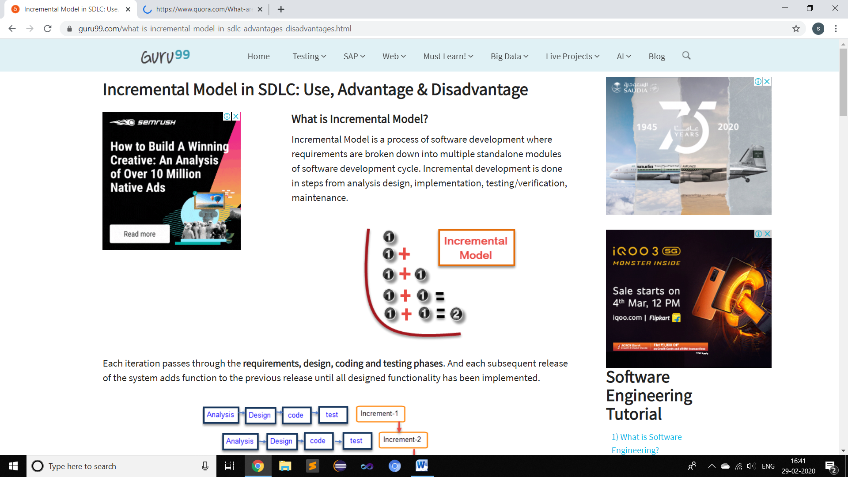

**Fig. Incremental Model**

* Each iteration passes through the**requirements, design, coding and testing phases.** And each subsequent release of the system adds function to the previous release until all designed functionality has been implemented.
* The system is put into production when the first increment is delivered. The first increment is often a core product where the basic requirements are addressed, and supplementary features are added in the next increments. Once the core product is analysed by the client, there is plan development for the next increment.
* Processing of incremental model can be described using following figure.

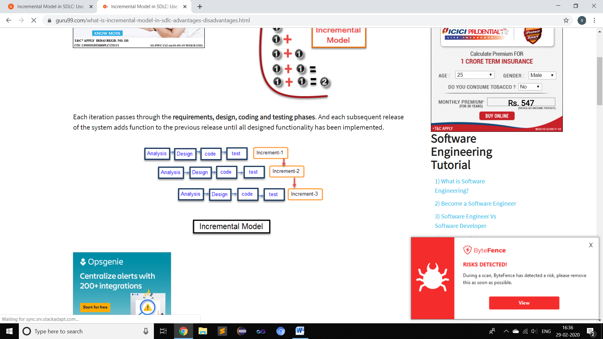

**Fig. 2.1: Incremental model**

* 1. **Advantages of Incremental Model:-**
* The software will be generated quickly during the software life cycle.
* It is flexible and less expensive to change requirements and scope.
* Throughout the development stages changes can be done.
* This Model is less costly compared to others.
* A customer can respond to each building.
* Errors are easy to identified.

**3.3 Disadvantages of Incremental Model:-**

* It requires a good planning designing.
* Problems might cause due to system architecture as such not all requirements collected up front for the entire software lifecycle.
* Each iteration phase is rigid and does not overlap each other.
* Rectifying a problem in one unit requires correction in all the units and consumes a lot of time.

**CHAPTER 4**

**Requirement Analysis & Feasibility Studies.**

**4.1 Software Requirement Specification:**

The software requirement specification is produced at the culmination of the analysis task. The function and performance allocated to software as part of system engineering are redefined by establishing a complete information description as functional requirement, a representation of system behaviour, an indication of performance requirement and design constraints, appropriate validation criteria.

**4.2 IDE Used:-**

* Eclipse is a widely used IDE primarily for Java development. Eclipse is used for C and C++ development as well as PHP among other programming languages
* Eclipse IDE is written in Java. It mainly consists of a base ‘Workspace’ and a plug-in system so that we can add more features to it through plugins and extend the functionality of the IDE.
* Eclipse works on all the major platforms including Windows, Mac OS, Linux, etc. and boasts of powerful features that can be used to develop full-fledged projects.

### Features Of Eclipse IDE:

* Almost everything in Eclipse is a plugin.
* We can extend the functionality of Eclipse IDE by adding plugins to the IDE, maybe for additional programming language or version control system or UML.
* Supports various source knowledge tools like folding and hyperlink navigation, grading, macro definition browser, code editing with syntax highlighting.
* Provides excellent visual code debugging tool to debug the code.
* Eclipse has a wonderful user interface with drag and drop facility for UI designing.
* Supports project development and administered framework for different toolchains, classic make framework, and source navigation.
* Java Eclipse IDE has a JavaDoc facility using which we can automatically create documentation for classes in our application.
* **Development Environment for Eclipse includes:**
* Eclipse Java Development Tools (JDT) for Java and Scala.
* Eclipse C/C++ Development Tools (CDT) for C/C++.
* Eclipse PHP Development Tools (PDT) for PHP.

**4.3 Server Used :**

Tomcat is a popular web container software designed to execute Java servlets and render web pages that use Java Server page coding. Accessible as either a binary or a source code version. Tomcat’s been used to power a wide range of applications and websites across the Internet. At this time, it’s definitely one of the more popular servlet containers available**.**

**Features:**

**1. Incredibly Lightweight**:-

Even with JavaEE certification, Tomcat is an incredibly lightweight application.If offers only the most basic functionality necessary to run a server, meaning it provides relatively quick load and redeploy times compared to many of its peers, which are bogged down with far too many bells and whistles. This lightweight nature also allows it to enjoy a significantly faster development cycle.

**2. Open-Source-**

It is an open source Server which means it is free of cost. Tomcat’s free, and the source code for the server is readily available to anyone who’d care to download it. What this means is that – assuming you’re willing to tinker with the moving parts of your server – you’ve got an incredible degree of freedom insofar as what you want to do with a Tomcat installation.

**3. Highly Flexible**

Thanks to its lightweight nature and a suite of extensive, built-in customization options,

Tomcat is quite flexible. You can run it in virtually any fashion you choose, and it’ll still

work as intended. The fact that it’s open-source helps as well, since you can tweak it to fit

your needs, provided you’ve the knowledge to do so.

**4.4 Language Used:-**

The Java programming language is designed to meet the challenges of application development in the context of heterogeneous, network-wide distributed environments.

Paramount among these challenges is secure delivery of applications that consume the minimum of system resources, can run on any hardware and software platform, and can be extended dynamically.

The Java programming language originated as part of a research project to develop advanced software for a wide variety of network devices and embedded systems.

Java has proven ideal for developing secure, distributed, network-based end-user applications in environments ranging from network-embedded devices to the World-Wide Web and the desktop.

**4.5 Frameworks Used:-**

**1) Hibernate:-**

* Hibernate is an open source Java persistence framework project.
* It performs powerful Object-relational mapping and query databases using HQL and SQL.
* Hibernate is a great tool for ORM mappings in Java. It can cut down a lot of complexity and thus defects as well from your application, which may otherwise find a way to exist.
* This is especially boon for developers with limited knowledge of SQL.
* **Hibernate Architecture**
  1. **Configuration** :

In hibernate.properties or hibernate.cfg.xml files. For Java configuration, you may find class annotated with @Configuration. It is used by Session Factory to work with Java Application and the Database. It represents an entire set of mappings of an application Java Types to an SQL database.

* 1. **Session Factory** :

Any user application requests Session Factory for a session object. Session Factory uses configuration information from above listed files, to instantiates the session object appropriately.

* 1. **Session** :

This represents the interaction between the application and the database at any point of time. This is represented by the org.hibernate.Session class. The instance of a session can be retrieved from the SessionFactory bean.

* 1. **Query** :

It allows applications to query the database for one or more stored objects. Hibernate provides different techniques to query database, including NamedQuery and Criteria API.

* 1. **First-level cache** :

It represents the default cache used by Hibernate Session object while interacting with the database. It is also called as session cache and caches objects within the current session. All requests from the Session object to the database must pass through the first-level cache or session cache. One must note that the first-level cache is available with the session object until the Session object is live.

* 1. **Transaction** :

Enables you to achieve data consistency, and rollback incase something goes unexpected.

* The following diagram summarizes the main building blocks in hibernate architecture.

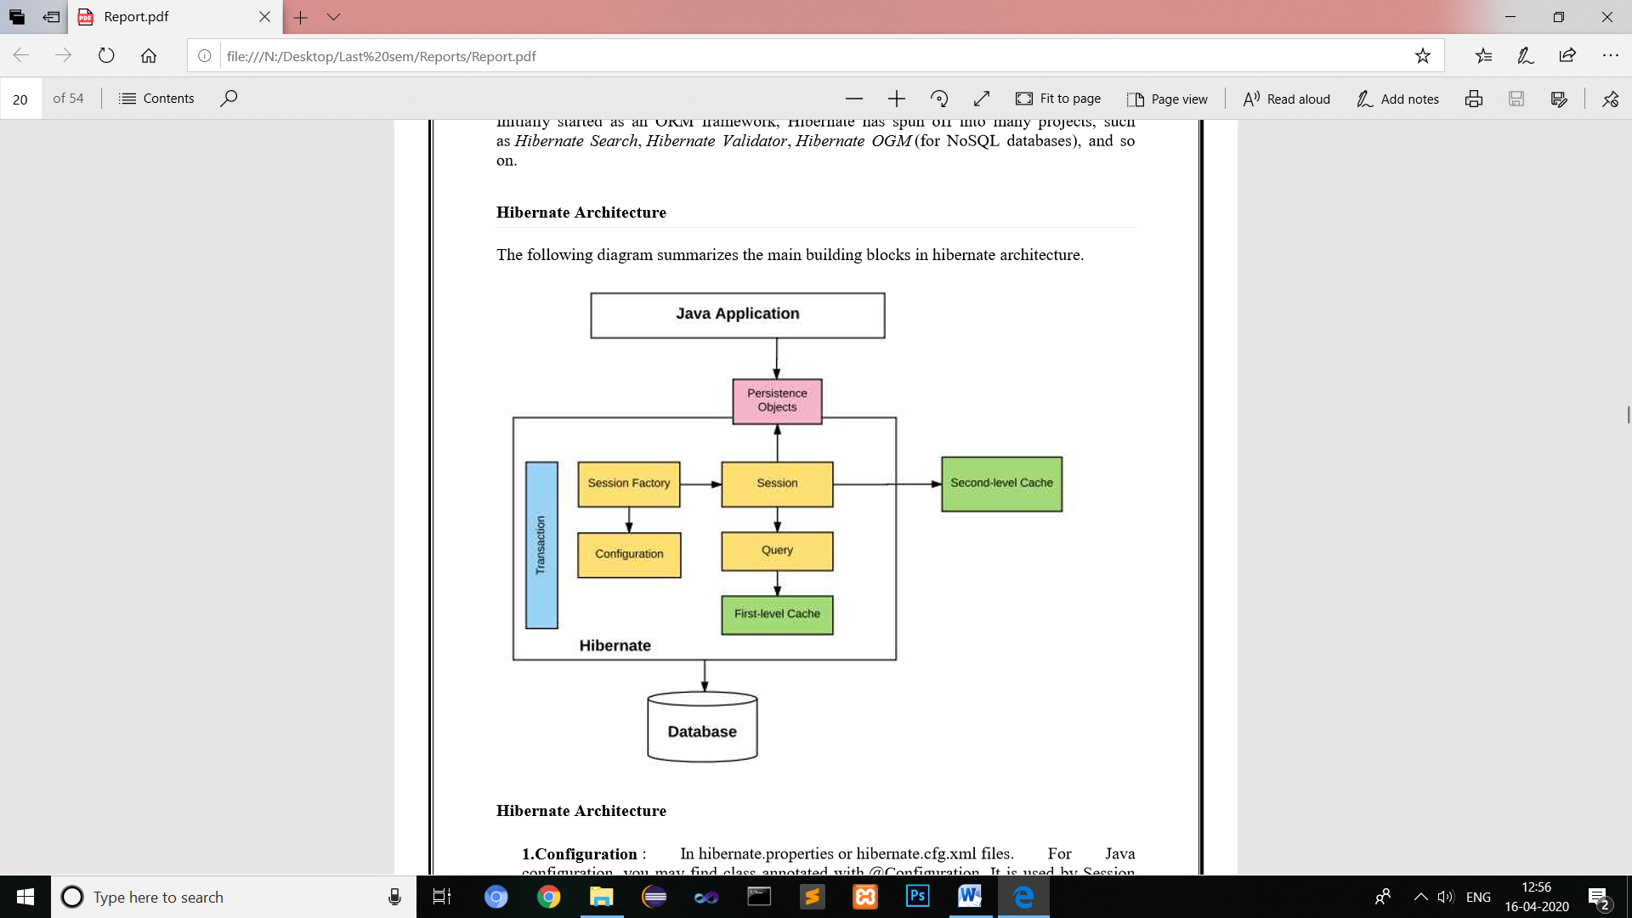

**Fig. Hibernate Architecture**

* **Why to use Hibernate technology –**
* Hibernate supports Inheritance, Associations, Collections.
* In hibernate if we save the derived class object, then its base class object will also be stored into the database, it means hibernate supporting inheritance
* Hibernate supports relationships like One-To-Many,One-To-One, Many-To-Many-to Many, Many-To-One
* This will also supports collections like List,Set,Map (Only new collections)
* In jdbc all exceptions are checked exceptions, so we must write code in try, catch and throws, but in hibernate we only have Un-checked exceptions, so no need to write try, catch, or no need to write throws. Actually in hibernate we have the translator which converts checked to Un-checked
* Hibernate has capability to generate primary keys automatically while we are storing the records into database
* Hibernate has its own query language ,i.e hibernate query language which is database independent
* Hibernate supports annotations, apart from XML
* So if we change the database, then also our application will works as HQL is database independent.

**2) Spring MVC:-**

A Spring MVC is a Java framework which is used to build web applications. It follows the Model-View-Controller design pattern. It implements all the basic features of a core spring framework like Inversion of Control, Dependency Injection.

A Spring MVC provides an elegant solution to use MVC in spring framework by the help of  **DispatcherServlet**. Here, **DispatcherServlet** is a class that receives the incoming request and maps it to the right resource such as controllers, models, and views.

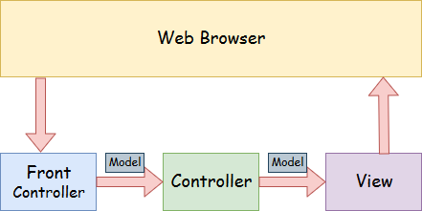

## Fig . Spring Web Model-View-Controller

## Model-view-controller:-

1. **Model** :-

A model contains the data of the application. A data can be a single object or a collection of objects.

1. **Controller** :–

A controller contains the business logic of an application. Here, the @Controller annotation is used to mark the class as the controller.

1. **View** :–

A view represents the provided information in a particular format. Generally, JSP+JSTL is used to create a view page. Although spring also supports other view technologies such as Apache Velocity, Thymeleaf and FreeMarker.

1. **Front Controller** :–

In Spring Web MVC, the DispatcherServlet class works as the front controller. It is responsible to manage the flow of the Spring MVC application.

## The Flow of Spring Web MVC:-https://i.stack.imgur.com/gNsOa.jpg

## Fig. Flow of Spring Web MVC

1. All the incoming request is intercepted by the DispatcherServlet that works as the front controller.
2. The DispatcherServlet gets an entry of handler mapping from the XML file and forwards the request to the controller.
3. The controller returns an object of ModelAndView.
4. The DispatcherServlet checks the entry of view resolver in the XML file and invokes the specified view component.

* **Advantages Of Spring MVC Framework:-**

1. **Separate roles** - The Spring MVC separates each role, where the model object, controller, command object, view resolver, DispatcherServlet, validator, etc. can be fulfilled by a specialized object.
2. **Light-weight** - It uses light-weight servlet container to develop and deploy your application.
3. **Powerful Configuration** - It provides a robust configuration for both framework and application classes that includes easy referencing across contexts, such as from web controllers to business objects and validators.
4. **Rapid development** - The Spring MVC facilitates fast and parallel development.
5. **Reusable business code** - Instead of creating new objects, it allows us to use the existing business objects.
6. **Easy to test** - In Spring, generally we create JavaBeans classes that enable you to inject test data using the setter methods.
7. **Flexible Mapping** - It provides the specific annotations that easily redirect the page.

**4.6 Browser Used:- Google Chrome**

**Features:**

**1.Task manager :-**

* Chrome has its own Task Manager that shows you how much memory and CPU usage each tab and plug-in is using.
* You can open it by clicking Shift-Esc from within Chrome.
* You can get more details by clicking the "Stats for nerds" link on the Task Manager and it will open a page with a full breakdown of memory and CPU usage for each process within the browser.

**2. Upgraded tabs :-**

* The Chrome development team views tabs as one of the best new innovations to Web browsing in recent years and so they wanted to expand the functionality of tabs since users .
* In Chrome you can drag a tab into its own window, and drag it back to the main window. This is called "Dynamic Tabs." Also, by default, the "New Tab" page in Chrome features a page that shows thumbnails of your most visited Web sites, a list of your recent bookmarks, and a search box that allows you to search your history.
  1. **Hardware Specification:-**

|  |  |
| --- | --- |
| **Content** | **Description** |
| Processors | i3,i5,i7 |
| Hard Drive | 1GB(minimum)  2GB(Recommended) |
| RAM | 512MB(minimum)  1GB(Recommended) |
| Operating System | Windows 10,Windows 7,Windows 8 |

**4.8 Database and other software specification:-**

|  |  |
| --- | --- |
| **Content** | **Description** |
| Language | HTML, JSP, JAVA, JAVASCRIPT, BOOTSTRAP,CSS |
| Database | MySQL |
| Framework | Hibernate ,Spring MVC |
| Dependency Manager | Maven |
| Server | Apache Tomcat |

**CHATER 5**

**Project User Interface Designing**

**Homepage:-**

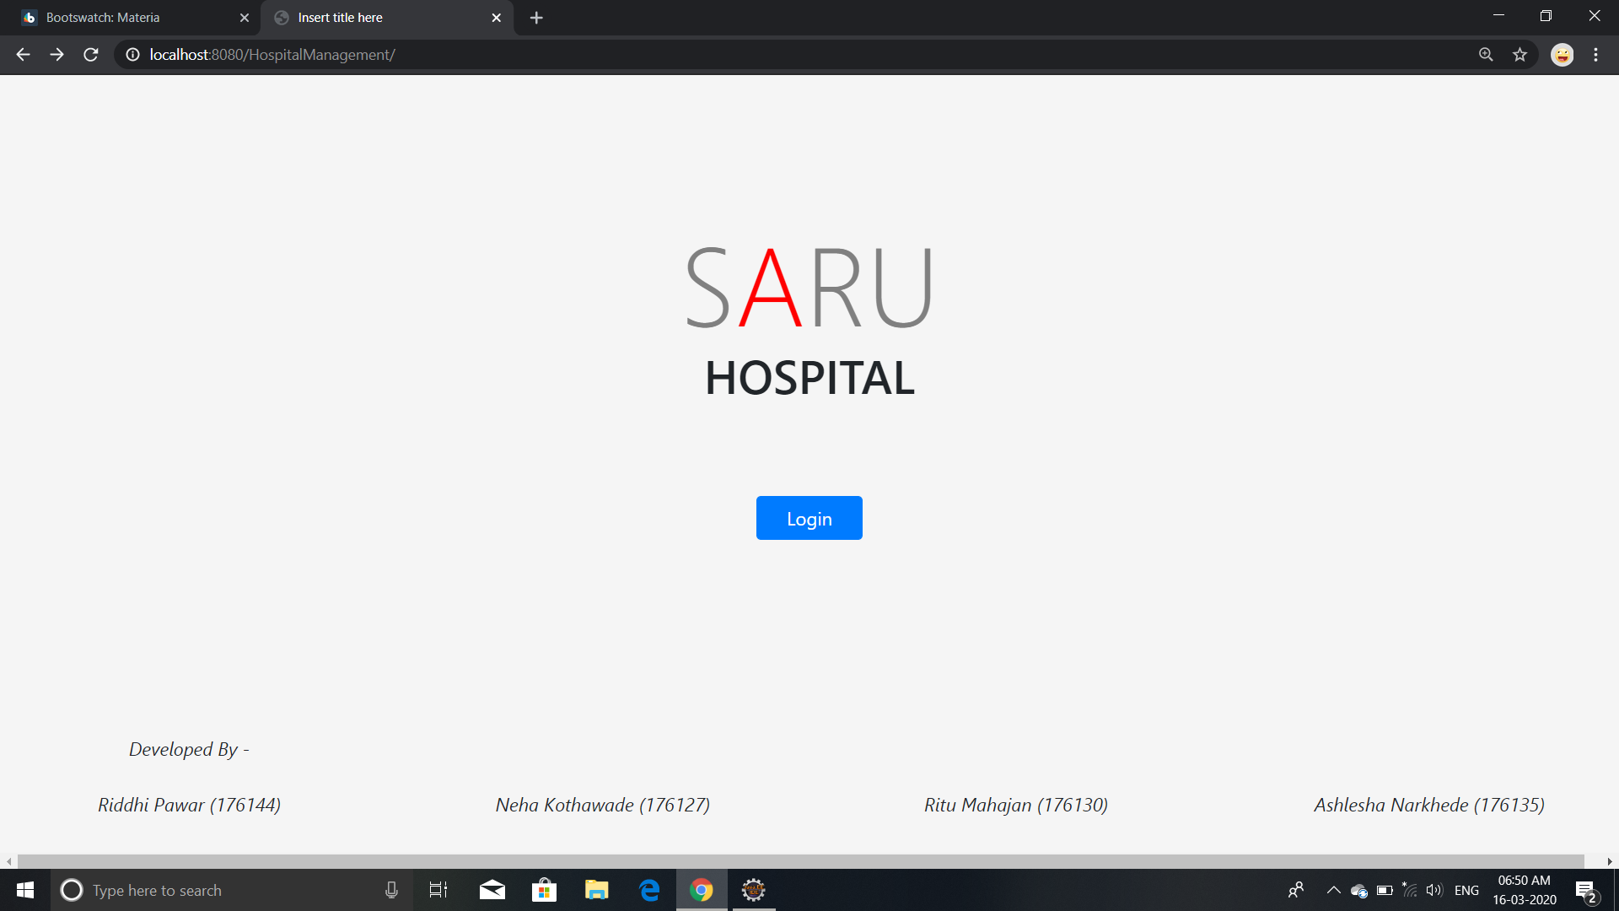

**Login Page:-**

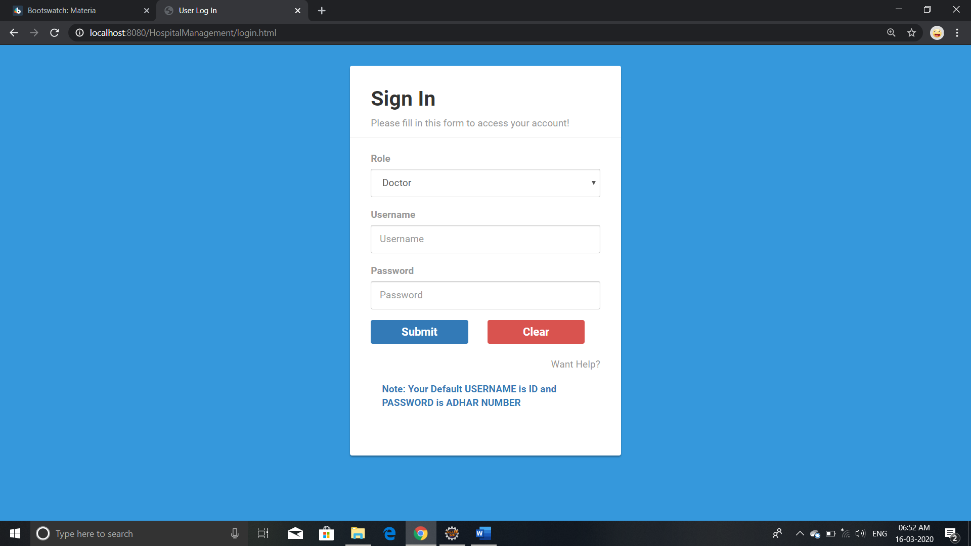

**Receptionist DashBoard:-**

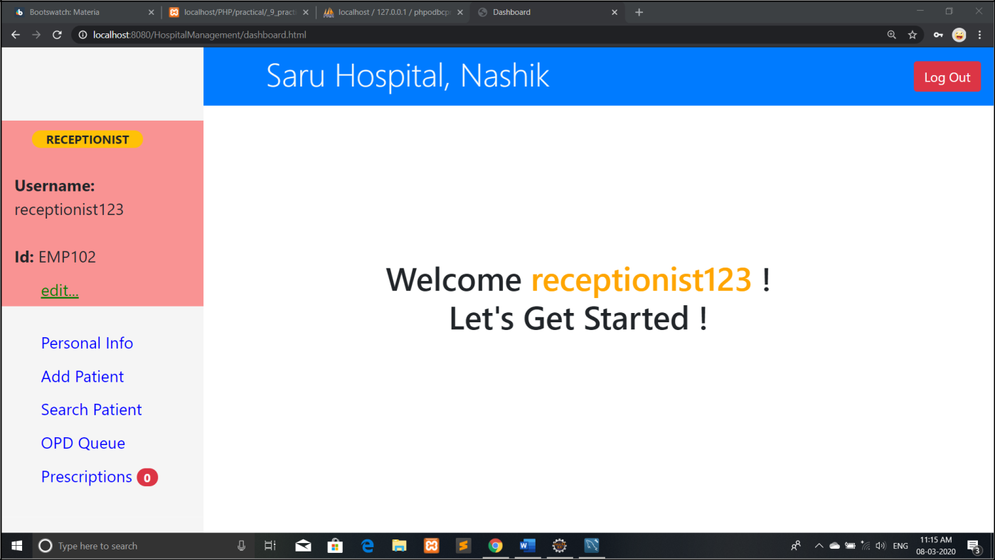

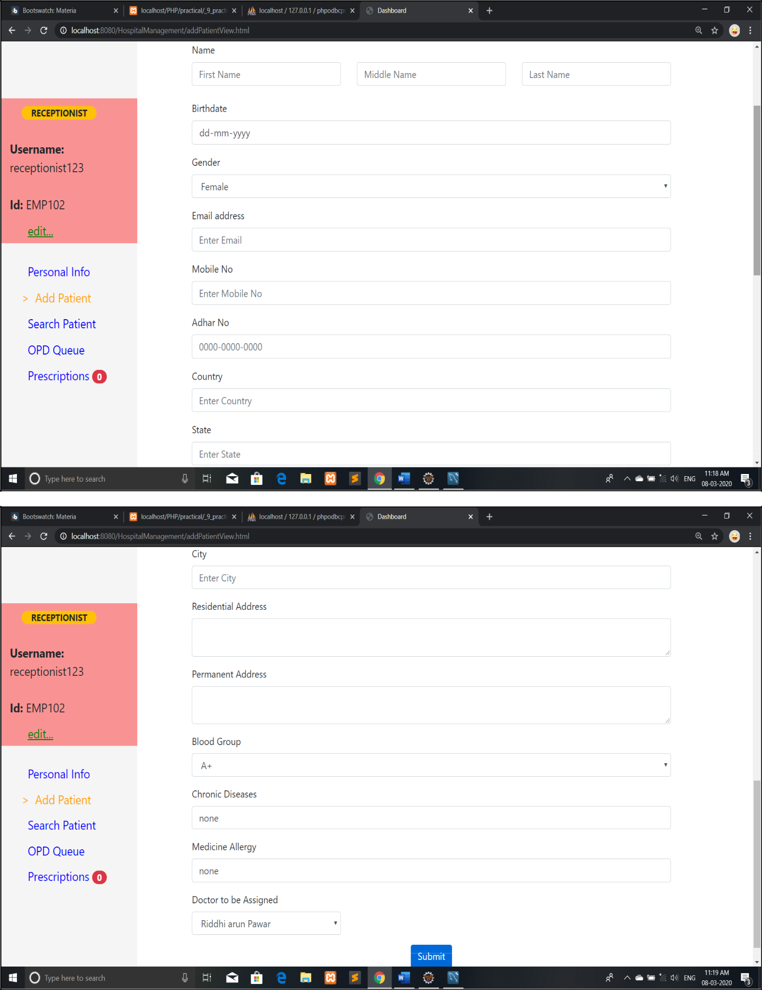**Add Patient:-**

**Search patient:-**

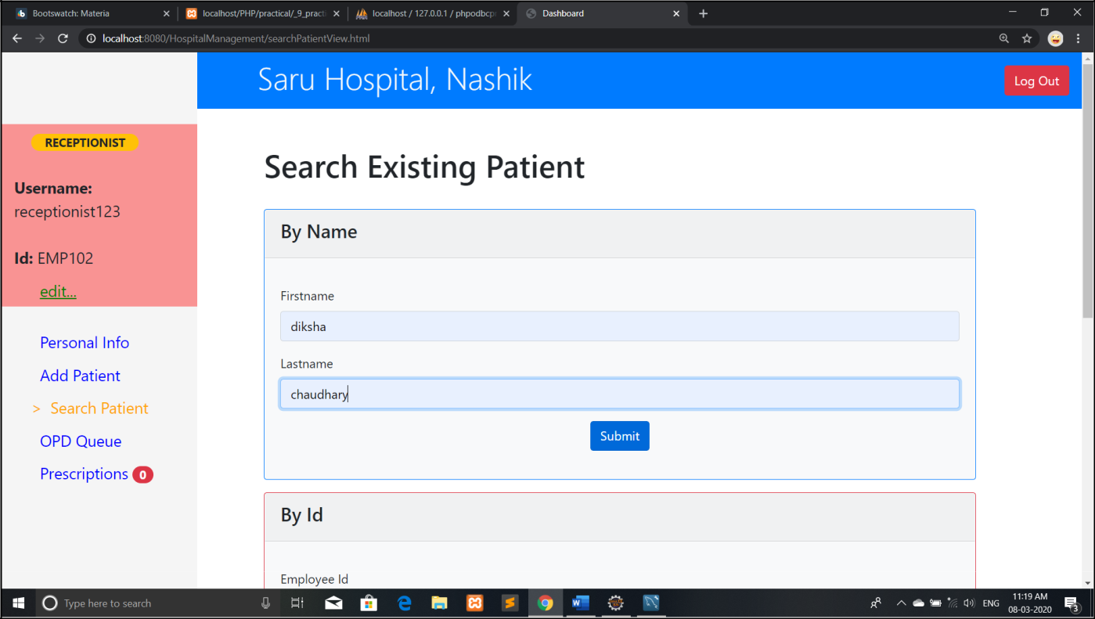

**OPD queue page:-**

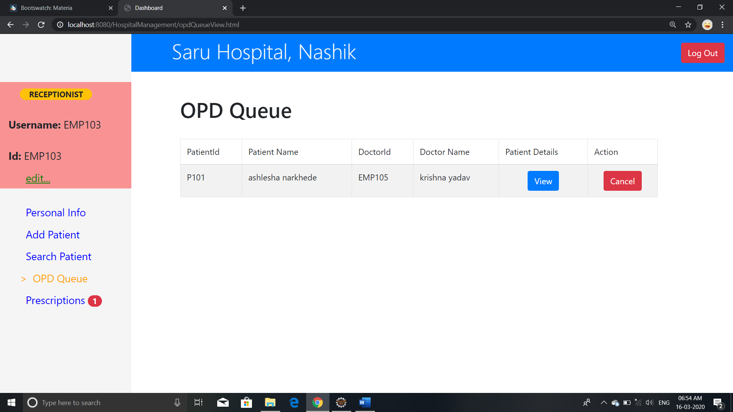

**Doctor DashBoard:-**

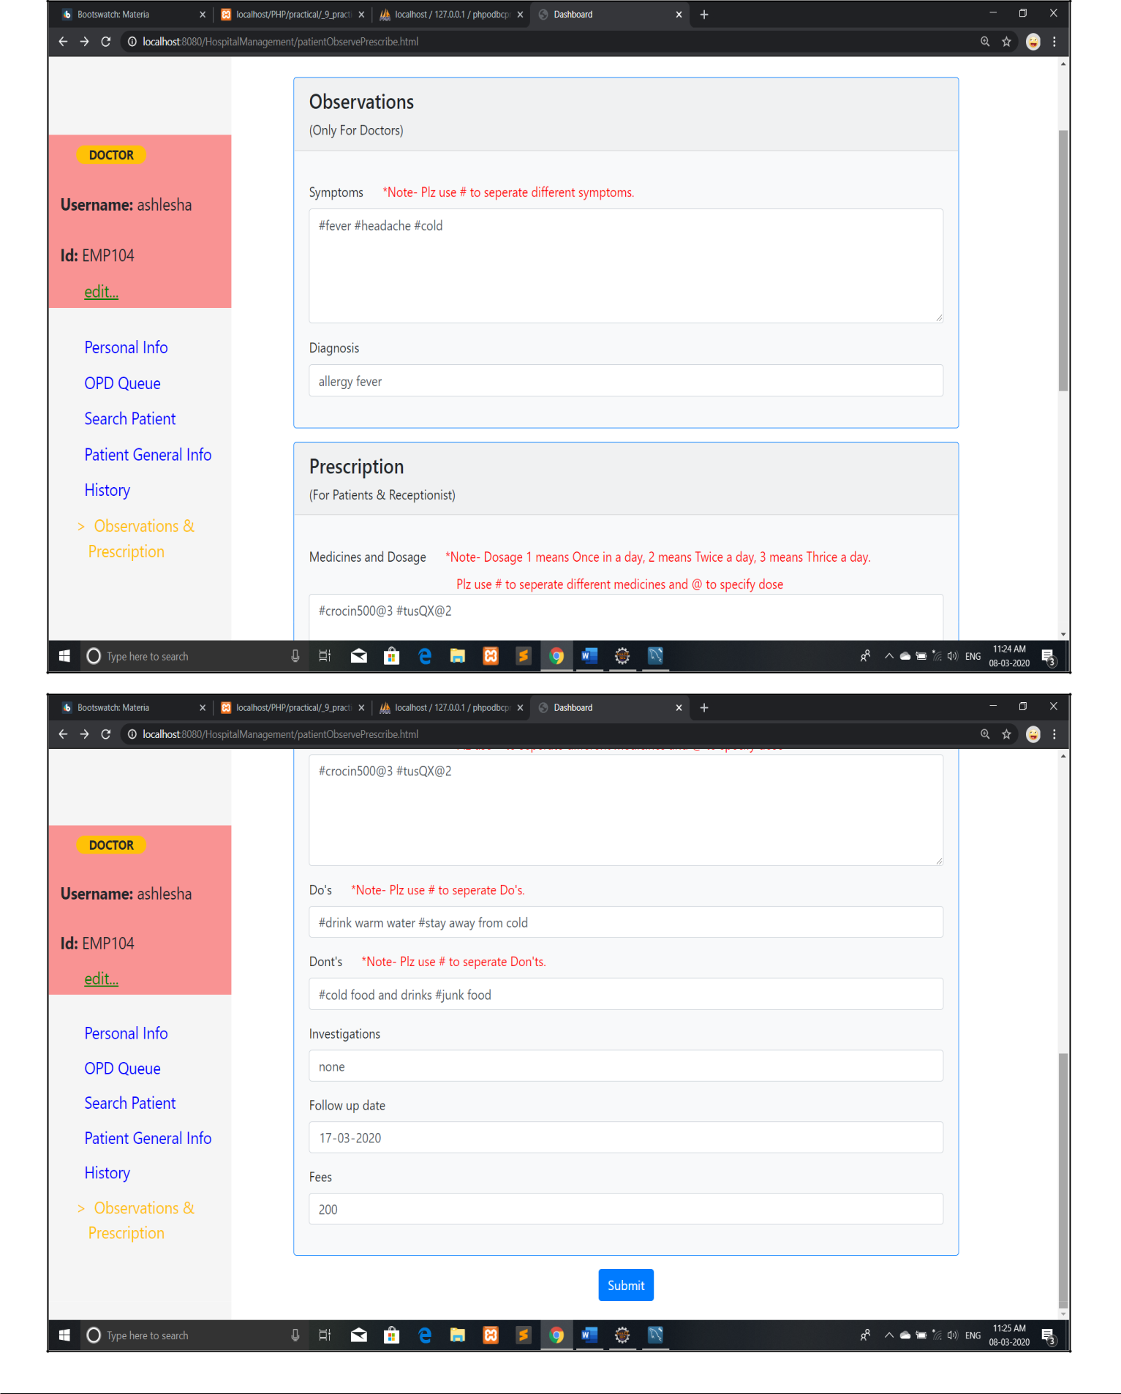

**Prescription:-**

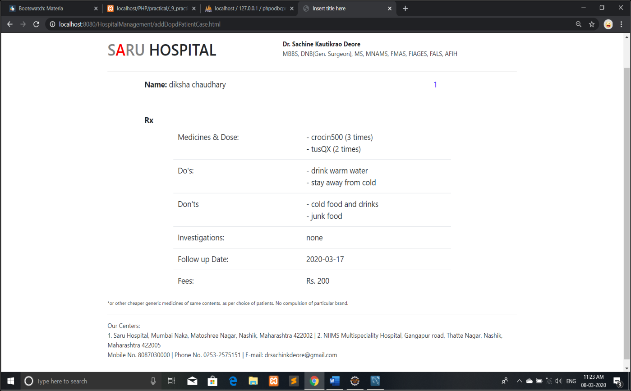

**Admin DashBoard:-**

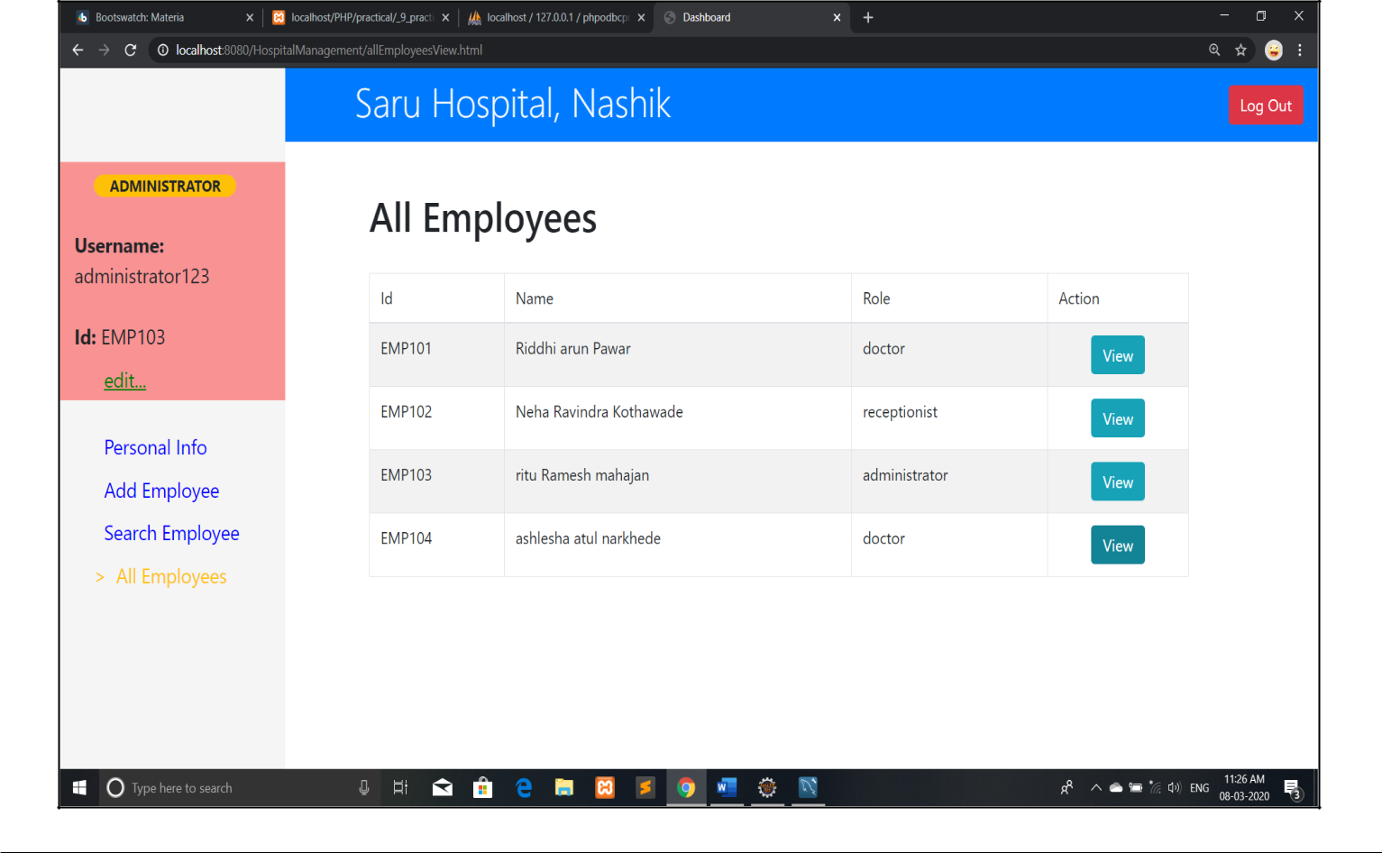

**CHAPTER 6**

**Feasibility study and System Testing**

**6.1 Feasibility study**

**6.1.1 Technical Feasibility:**

This is concerned with specifying equipment and software that will successfully satisfy the user requirement; the technical needs of the system may vary considerably, but might include:

* 1. The facility to produce outputs in a given time.
  2. Response time under conditions.
  3. Ability to process a certain volume of transaction at a particular time.
  4. Facility to communicate data to distant location.

**6.1.2 Operational Feasibility**:

It is mainly related to human organization and political aspects. The points to be considered are:

1. What changes will be brought with the system?
2. What organizational structures are distributed?
3. What new skills will be required? Do the existing staff members have these skills? If not, can then the trained in course of time ?

**6.1.3 Economic Feasibility**:

Economic analysis is the most frequently used technique for evaluating the effectiveness of a proposed system. More frequently known as cost/benefit system and compare them with costs. If benefits outweigh costs, a decision is taken to design and implement the system.

**6.1.4 Management Feasibility**:

It is a determination of whether a proposed project will be acceptable to management. If does not accept a project of gives a negligible support to it; the analyst will tend to view the project as a no feasible one.

**6.1.5 Social Feasibility**:

Social feasibility is a determination of whether the project will be acceptable to the people or not. This determination typically examines the probability of the project accepted by the group directly affected by the proposed system change.

**6.2 Testing:-**

**6.2.1 Unit Testing**

Unit testing performed on each module or block of code during development. Unit testing is normally done by the programmer who writes the code.

**6.2.2 Integration Testing**

Integration testing done before, during and after integration of a new module into the main software package. This involves testing of each individual code module. One piece of software can contain several modules which are often created by several different programmers. It is crucial to test each modules effect on the entire program model. After integration testing the project works successfully.

**6.2.3 System Testing**

System testing done by a professional testing agent on the completed software product before it is introduced to the market.

**6.2.4 Acceptance Testing**

Acceptance testing is a beta testing of the product done by the actual end user.

**6.2.5 Security Testing**

Security Testing is a variant of Software Testing which ensures, that system and applications in an organization, are free from any loopholes that may cause a big loss. Security testing of any system is about finding all possible loopholes and weaknesses of the system which might result into a loss of information at the hands of the employees or outsiders of the Organization .

**6.2.6 Functional Testing**

Functional Testing also known as functional completeness testing. Functional Testing involves trying to think of any possible missing functions. Testers might make a list of additional functionalities that a product could to improve it during functional testing.

**6.2.7** **Recovery Testing**

Recovery testing is done to demonstrate a software salutation is reliable, trustworthy and can successfully recoup from possible crashes.

**6.2.8 Hardware/Software Testing**

IBM refers to Hardware/Software testing as “HW/SW Testing”. This is when the tester focuses his/her attention on the interactions between the hardware and software during system testing.

**Test Cases:-**

|  |  |  |  |  |  |  |  |
| --- | --- | --- | --- | --- | --- | --- | --- |
| **Sr.**  **No.** | **Test**  **Case**  **ID** | **Test Case**  **Objective** | **Steps** | **I/P Data** | **Expected**  **Result** | **Actual**  **Result** | **Status** |
| 1 | TC_01 | To check the functionality of login form | Click on Submit button | 1.Role  2.Username3.Password | If username and password is correct then  Doctor/receptionist  /administrator panel will be open otherwise display flash data on login page. | **Case 1**: As username or password or both are incorrect flash data is displayed on login page.    **Case 2**: As username and password is correct, Login successful and appropriate panel is opened | Pass |
| 2 | TC_02 | To check  Functionality  of select role  option on  login page. | Select the  role to log  in | Select option to login | It will show  dropdown list to  select role | Displays the list  to select the  role | Pass |
| 3 | TC_03 | To check the length of username | Enter  Username  on login  page | username | It must accept the username with maximum length of 20 characters | **Case 1:**  If user name is  of maxlength  20 character  then cursor  goes to  password.  **Case 2:**  If username is  greater than 20  character then I  will show error  message | Pass |
| 4 | TC_04 | To check the length of password | Enter password on login page | password | It must accept  the password  with  minimum and  maximum  length of 8  characters | If password is  of length of 8  character then  user can log in | Pass |
| 5 | TC_05 | To check the  Functionality  of submit  button | Click on submit button | - | It will submit the  data to database  and refresh the  page | Save data in  database and  display refreshed  page | Pass |
| 6 | TC_06 | To check the functionality of clear button | Click on Clear  button | - | Login details will be cancelled. It will clear field in login form. | Login data is cancelled . | Pass |
| 7 | TC_07 | To check the functionality of personal info option | Click on personal info to edit personal details about employee /staff in hospital. | Edit personal information. | It will update  the data which is  edited. | Employee/Staff  profile  is updated successfully. | Pass |
| 8 | TC_08 | To check functionality of Add patient Option. | Click on  Add Patient link. | Fill the data in the registration form. | Data will be save in database and message (Patient registered) will be display. | Data is saved in database and message is displayed. | Pass |
| 9 | TC_09 | To check the functionality of Edit Button in form. | Click on  EDIT  button | Edit the data in form | Patient registration page will be open for edit registration | Patient registration page is opened  to edit registration. | Pass |
| 10 | TC_10 | To check the  Functionality  of search  patient option | Click on  Search  patient | - | It will display  the options for  searching  patient | Display option  for searching  patient. | Pass |
| 11 | TC_11 | To check the  Functionality  of search  patient by Id | Click on  Search  patient by  Id | Enter  Existing  patient id | Case1:  It will display the  patient the  patient info if  patient exists.  Case2:  If patient does  not exists then It  will display  message “not  found” | It will display  Patient  information. | Pass |
| 12 | TC_12 | To check the functionality of search by aadhar number | Click on search patient by aadhar number | Enter valid aadhar number of 12 digits | Case1:  If patient registered with specified aadhar found then it will display patient info.  Case2:  If patient with aadhar number not found then it displays “not found” | It will display specified patient information | Pass |
| 13 | TC_13 | To check  Functionality  of search by  mobile  number  option | Click on  search by  mobile  number. | Enter  Valid  Mobile  number of  10 digit | Case1:  If patient with  specified mobile  number found  then displays  patient info.  Case2:  If patient with  specified mobile  number no  found then  display “not  found” | It will display  the information  of specified  patient | Pass |
| 14 | TC_14 | To check the functionality of OPD queue option. | Click on OPD Queue | - | It will display the list of patients who are added in OPD queue. | It Shows list of patients in OPD  Queue. | Pass |
| 15 | TC_15 | To check the  Functionality  of VIEW  button in OPD  queue . | Click on  View  button. | - | It will display  Detailed  information of  patient. | Detailed  information of  patient is  displayed. | Pass |
| 16 | TC_16 | To check  functionality  of Cancel  button on  OPD Queue  List. | Click on cancel button | - | It will delete the  patients record  from OPD queue  list. | Delete the  record from list  and display  updated list | Pass |
| 17 | TC_17 | To check the functionality of PRINT  button available in prescription option. | Click on  PRINT  button | - | Printing settings will be opened | Printing settings are opened. | Pass |
| 18 | TC_18 | To check functionality of History option | Click on history | - | It will Shows History of particular patient if exists | Display history of patient | Pass |
| 19 | TC_19 | To check functionality of observation and prescription option. | Click on observation and prescription | - | It will display the observation and prescription of patient if exists | Displays the prescription and observation of patients. | Pass |
| 20 | TC_20 | To check the functionality of Edit option | Click on Edit option to edit username and password. | Edit username and password. | It will update  Username and  Password  which  Is edited. | Username and  password are  updated  successfully. | Pass |
| 21 | TC_21 | To check Functionality Of add employee | Click on add employee | - | It will display employee registration form. | Display employee registration form. | Pass |
| 22 | TC_22 | To check functionality of all employee option. | Click on all employee | - | It will display all employee in Hospital. | Displays all employee in the Hospital. | Pass |
| 23 | TC_23 | To check functionality of log out button. | Click on log out button. | - | It will logout the user and control redirects to log in page | Log out current account and redirected to login page | Pass |

**CHAPTER 7**

**System Implementation**

**7.1. Implementation :**

* Implementation is the process of having system personal check out and provides new equipment’s into use, train the user to install a new application and construct any files of data needed to use it. There are three types of implementation.
* Implementation of computer system to replace a manual system. To problem encountered are covering files, training user, creating accurate files and verifying print outs for integrity. Implementation of a new computer system to replace an existing one.
* This is usually difficult conversion. If not properly planned, there can be many problems. Implementation of a modified application to replace the existing one using the same computer.
* This type of conversing is relatively easy to handle, usually there are no major change in the file. Our project is yet to be implemented.

**7.2 Web Application :**

* Here, the web application corresponds with the idea of the Hospital Management System. It is a Web Application with Java as its base programming language and comprises of JSP as its fundamental building aspect. Along with JSP, it consists of
  1. CSS Files
  2. Bootstrap Files
  3. Java Class Files
  4. Configuration Files ,etc.
* **JSP Pages :-**

As the fundamental working aspect of the application is a JSP page, the entire business logic and web designing essentials are to be nested within the same JSP page. However this may lead to a cumbersome merge of code which may lead the individual functionalities tomisbehave. Thus, each separate functionality is designed inside another JSP page and these JSP pages are merged in the main page.

* **Functionality** :-

Functionality refers to one individual action out of the various possible tasks an intended user would do. As mentioned earlier, each functionality is linked to a separate JSP page. The components of this JSP page are mentioned in the further section.

**7.3 Database Design**

Database design is the process of producing a detailed data model of database. This data model contains all the need logical and physical design choices and physical storage parameters needed to generate a design in a data definition language, which can then be used to create a database. A fully attributed data model contains detailed attributes for each entity.

The term database design can be used to describe many different part of the design of an overall database system. Principally, and most correctly, it can be thought of as the logical design of the base data structure used to store the data. In the relational model these are the tables and views.

**7.4 Database schema of Hospital Management System**

* A database schema is the skeleton structure that represents the logical view of the entire database. It defines how the data is organized and how the relations among them are associated. It formulates all the constraints that are to be applied on the data.
* A database schema can be divided broadly into two categories –
  1. **Physical Database Schema:** This schema pertains to the actual storage of data and its form of storage like files, indices, etc. It defines how the data will be stored in a secondary storage.
  2. **Logical Database Schema:** This schema defines all the logical constraints that need to be applied on the data stored. It defines tables, views, and integrity constraints.
* **List of table:**

1. Login.
2. Admin.
3. Patients
4. OPD .
5. Opddetails
6. Idgenerator
7. Employee

**CHAPTER 8**

**OTHER ASPECTS**

**8.1 Advantages:**

After the customized software is implemented and integrated into the system, patient care and hospital administration becomes an easy job.

1. Makes prescription readable and understandable to patients.
2. Eliminate redundancy in term of data storage. Data will be stored in a computer not heap of files.
3. Reduce the time wasted in retrieving data especially in finding a past health records.
4. Increase Efficiency and Interactivity in any area of specialization in the hospital.
5. Able to quickly collect and edit data, summarize result and adjust as well as collect errors promptly.
6. Uses Bcrypt encoding technique to store passwords hash for secure logins.

**8.2 Limitations of the system:**

1. Patients don’t have any role.
2. No Live Queue feature.

**8.3 Applications:**

1. For small or middle scale hospitals .
2. For managing Opd Queue.

**8.4 Future plan:**

1. To include Patient module.
2. To manage IPD section.

**CHAPTER 9**

**Conclusion And Reference**

This project helps in making paperless activities. It reduces the workload from Doctor and Receptionist. It provides more ease and flexibility to Doctor, Administrator and Receptionist.

This digitalization has reduced costs of Hospital. This work has created a little awareness and promotes the idea that the concept of paperless office is reality.

**References :-**

* <https://www.youtube.com/watch?v=BkRZfxznaOo>
* https://www.youtube.com/watch?v=JR7-EdxDSf0
* https://www.devglan.com/spring-mvc/storing-hashed-password-database-java
* <https://www.freestudentprojects.com/studentprojectreport/projectreport/hospital-management-system-project-report/>.
* <https://www.academia.edu/7149341/HOSPITAL_MANAGEMENT_SYSTEM_A_PROJECT_REPORT_Submitted_in_Partial_Fulfillment_of_the_requirements_for_the_Award_of_the>.
* <https://www.academia.edu/7149341/HOSPITAL_MANAGEMENT_SYSTEM_A_PROJECT_REPORT_Submitted_in_Partial_Fulfillment_of_the_requirements_for_the_Award_of_the>.
* <https://sites.google.com/site/ignoubcafinalyearprojects/project-report/hospital-management-system-project-report>.